EXPERIMENT-6

EE305 REPORT

O.C. AND S.C. TESTS ON SINGLE PHASE TRANSFORMER

- B. CHITTI LIKHITHA (511810)

**O.C. AND S.C. TESTS ON SINGLE PHASE TRANSFORMER**

**Aim:** To predetermine the efficiency, percentage regulation and equivalent circuit parameters of a given single phase transformer by conducting Open circuit and Short circuit tests on it.

**Name Plate**: Transformer Ratings: 2kVA , (0-240)V , 10A.

Rated Current: 8.33A

**Apparatus Required**:

|  |  |  |  |  |
| --- | --- | --- | --- | --- |
| S.No | Name of apparatus | Type | Range | Quantity |
| 1 | Ammeter | MI | (0-1)A | 1 |
| 2 | Ammeter | MI | (0-10)A | 1 |
| 3 | Voltmeter | MI | (0-150)V | 1 |
| 4 | Voltmeter | MI | (0-75)V | 1 |
| 5 | Wattmeter | LPF | 5A,150V | 1 |
| 6 | Wattmeter | UPF | 10A,75V | 1 |
| 7 | 1-Ø Variac | - | 230V/(0-270)V 15A | 1 |
| 8 | Connecting Wires | - | - | 1 set |

**THEORY:**

Open Circuit Test: The main purpose of this test is to find the iron loss and no load current which are useful in calculating core loss resistance and magnetizing reactance of the transformer. In O.C. test primary winding is connected to a.c supply ,keeping secondary open. Sometimes a voltmeter may be connected across secondary as voltmeter resistance is very high &voltmeter current is negligibly small so that secondary is treated as open circuit. Usually low voltage side is used as primary and high voltage side as secondary to conduct O.C. test. When primary voltage is adjusted to its rated value with the help of variac, readings of ammeter and wattmeter are to be recorded. Ammeter gives no load current. Transformer no load current is always very small, 2 to 5 % of its full load current. As secondary is open, I2= 0, hence secondary copper losses are zero. And I1=I0is very low hence copper losses on primary are also very low. Thus the total copper losses in O.C. test are negligibly small, hence neglected. Therefore the wattmeter reading in O.C. test gives iron losses which remain constant for all the loads. Short Circuit Test: The main purpose of this test is to find full load copper loss and winding parameters (R01&X01or R02& X02) which are helpful for finding regulation of transformer. In this test, secondary is short circuited with the help of ammeter. (secondary may be short circuited with thick copper wire or solid link).As secondary is shorted, its resistance is very very small and on rated voltage it may draw very large current. Such large current can cause overheating and burning of the transformer. To limit this short circuit current, primary is supplied with low/reduced voltage(5 –15% of the rated voltage)which is just enough to cause rated current to flow through primary which can be observed on an ammeter. The reduced voltage can be adjusted with the help of variac. The wattmeter reading as well as voltmeter, ammeter readings are recorded. As the voltage applied is low which is a small fraction of the rated voltage and iron losses are function of applied voltage, hence iron losses are negligibly small. Since the currents flowing through the windings are rated currents hence the total copper loss is full load copper loss. Hence the wattmeter reading is the power loss which is equal to full load copper losses.

**Procedure:**

**Open circuit test:**

1. Connections are made as per circuit diagram.
2. Ensure that variac is set to zero voltage position before starting the experiment and HV should be kept open.
3. Switch ON the supply & now apply rated voltage to primary (LV windings).
4. Readings of ammeter, voltmeter and wattmeter are noted down.
5. Variac is set to zero output position and switch off the supply and calculate Ro and Xo from readings.

**Short circuit test:**

1. Connections are made as per circuit diagram.
2. Ensure that variac is set to zero output voltage position before starting the experiment.
3. Switch ON the supply & now apply rated voltage to primary windings.
4. Readings of ammeter, voltmeter and wattmeter are noted down.
5. Variac is set to zero output position and switch off the supply and calculate Ro₂ and Xo₂ from readings.

**Circuit Diagrams:**

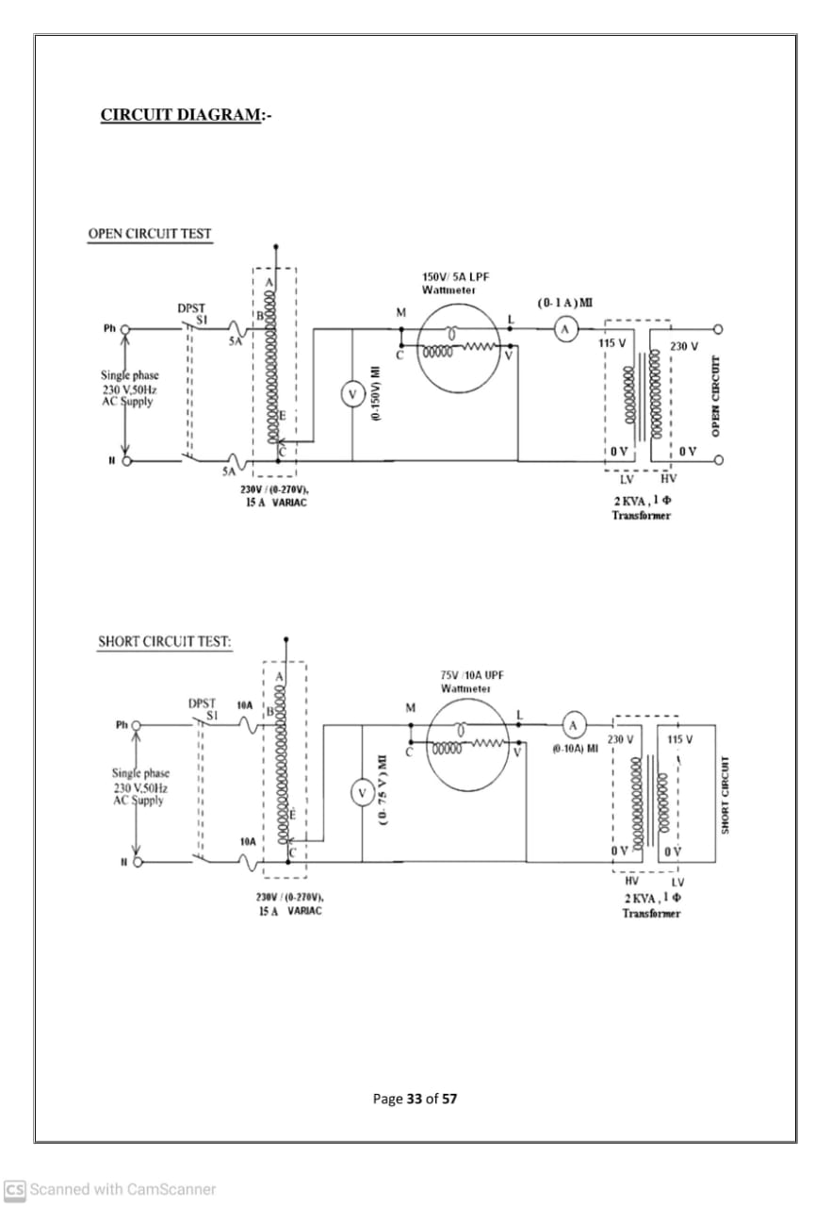

**Observations:**

**For open circuit test:**

|  |  |  |  |  |  |  |
| --- | --- | --- | --- | --- | --- | --- |
| Vₒ  (V) | Iₒ  (A) | Wₒ  (W) | CosØₒ=  Wₒ/VₒIₒ | SinØₒ=  √1-cos ²Øₒ | Rₒ=  Vₒ/Iₒ CosØₒ | Xₒ=  Vₒ/Iₒ SinØₒ |
| 115 | 1.08 | 48 | 0.3865 | 0.9223 | 275.515 | 115.45 |

**For short circuit test:**

|  |  |  |  |  |  |  |
| --- | --- | --- | --- | --- | --- | --- |
| Vsc  (V) | Isc  (A) | Wsc  (W) | CosØsc=  Wsc/VscIsc | Rsc=  Wsc/I²sc | Zsc=  Vsc/Isc | Xsc=  √Zsc²-Rsc² |
| 12.2 | 8.7 | 80 | 0.7537 | 1.0569 | 1.4023 | 0.9216 |

**Calculations:**

**OC test:**

Vₒ=115v , Iₒ=1.08A , Wₒ=48W

CosØₒ= Wₒ/VₒIₒ = 48 / (115*1.08) = 0.3865

SinØₒ= √1-cos ²Øₒ = √1-0.3865² = 0.9223

Rₒ= Vₒ/Iₒ CosØₒ = 115 /( 1.08*0.3865) = 275.515Ω

Xₒ= Vₒ/Iₒ SinØₒ= 115/(1.08*0.9223) = 115.45 Ω

**SC test:**

Vsc=12.2v , Isc=8.7A , Wsc=80W

CosØsc= Wsc/VscIsc = 80/ (12.2*8.7) = 0.7537

Rsc= Wsc/I²sc = 80/ 8.7² = 1.0569 Ω

Zsc= Vsc/Isc = 12.2 / 8.7 = 1.4023 Ω

Xsc= √Zsc²-Rsc² = √1.4023² -1.0569² = 0.9216 Ω.

**Tabular form:**

|  |  |  |  |  |  |
| --- | --- | --- | --- | --- | --- |
| CosØ | SinØ | **% Regulation**  **Lagging P.F Leading P.F** | | | |
| **Full Load** | **Half Load** | **Full Load** | **Half Load** |
| 0.2 | 0.9798 | 4.215 | 2.107 | -2.616 | -1.308 |
| 0.3 | 0.9539 | 4.525 | 2.262 | -2.126 | -1.063 |
| 0.4 | 0.9165 | 4.794 | 2.397 | -1.596 | -0.798 |
| 0.5 | 0.866 | 5.018 | 2.509 | -1.02 | -0.51 |
| 0.6 | 0.8 | 5.187 | 2.593 | -0.39 | -0.195 |
| 0.7 | 0.7141 | 5.2878 | 2.6439 | 0.3091 | -0.1545 |
| 0.8 | 0.6 | 5.2899 | 2.6449 | 1.1066 | 0.5533 |
| 0.9 | 0.4359 | 5.1176 | 2.5588 | 2.0785 | 1.0392 |
| 1.0 | 0 | 3.9978 | 1.9989 | 3.9978 | 1.9989 |

**Tabular form:**

|  |  |  |  |  |  |  |  |  |  |
| --- | --- | --- | --- | --- | --- | --- | --- | --- | --- |
| **X** | **Iron**  **Losses**  **Wi (w)** | **Copper**  **Losses**  **Wcu (W)** | **Total**  **Losses**  **(W)** | **Output (W)**  **X . kVA cos**Ø | | **Input (W)**  **O/P+ total losses** | | **η = $\frac{output}{input}$* 100** | |
| **cosØ=1** | **cosØ=0.8** | **cosØ=1** | **cosØ=0.8** | **cosØ=1** | **cosØ=0.8** |
| 0.1 | 48 | 0.8 | 48.8 | 200 | 160 | 248.8 | 208.8 | 80.38 | 76.63 |
| 0.2 | 48 | 3.2 | 51.2 | 400 | 320 | 451.2 | 371.2 | 88.65 | 86.21 |
| 0.3 | 48 | 7.2 | 55.2 | 600 | 480 | 655.2 | 535.2 | 91.57 | 89.69 |
| 0.4 | 48 | 12.8 | 60.8 | 800 | 640 | 860.8 | 700.8 | 92.94 | 91.32 |
| 0.5 | 48 | 20 | 68 | 1000 | 800 | 1068 | 868 | 93.63 | 92.17 |
| 0.6 | 48 | 28.8 | 76.8 | 1200 | 960 | 1276.8 | 1036.8 | 93.98 | 92.59 |
| 0.7 | 48 | 39.2 | 87.2 | 1400 | 1120 | 1487.2 | 1207.2 | 94.13 | 92.78 |
| 0.8 | 48 | 51.2 | 99.2 | 1600 | 1280 | 1699.2 | 1379.2 | 94.16 | 92.81 |

.

**Precautions:**

1. Avoid loose and wrong connections in the circuit.
2. Avoid parallax error while taking readings.
3. Make sure that variac is OFF after bringing it to zero output position.
4. Apply the reduced voltage (only 5 to 10% of rated voltage) slowly to HV side during SC test.

**Result:**

The parameters of a 1- Ø transformer are determined by conducting open circuit test and short circuit test on 1- Ø transformer.